**Steps I followed to complete the code part and committing the code to GIT repository:**

1. I have created a Scala Project named **CodeExercise** in Eclipse IDE and then created a Package named **Pack** and created an object **Lseg.**
2. I have configured it according to my local directory setup.
3. Then I have created SparkContext and SparkSession to develop the code using RDDs and DataFrames.
4. Then I have loaded the data from a file path which is passed as an argument to the program as shown below(i.e, highlighted part is the text path which I had on my local, so change the input path accordingly ), You can see the below option when you run your Scala application by selecting it from the "Run Configurations".

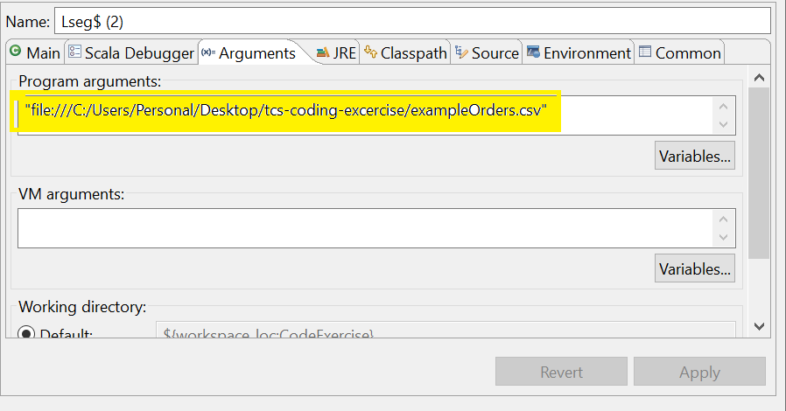

1. In the code **ordersRDD** reads the input file and **finalRDD** to impose the schema using case class **Order** which I have created outside the object.
2. **finalRDD** is converted to a Dataframe which is **ordersDF,** created a temp view named **orders** which can be used as a table to query on it.
3. **MatchesDF** matches the records based on Quantity and the filterouts with requirements according to the problem statement.
4. **finalopDF** is used to select only the required columns, result of the output for the given example input file is shown below.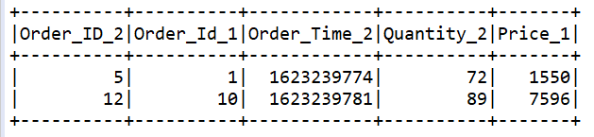

**Committing code to GIT:**

1. Right click on project -> Team -> Shareproject, then I have created a new repository then clicked on finish.
2. Right click on project -> Team -> Commit, add the files from Unstaged changes to Staged changes and add a commit message.
3. Right click on project -> Team -> PushBranchMain -> provided the required repository details along with username and password.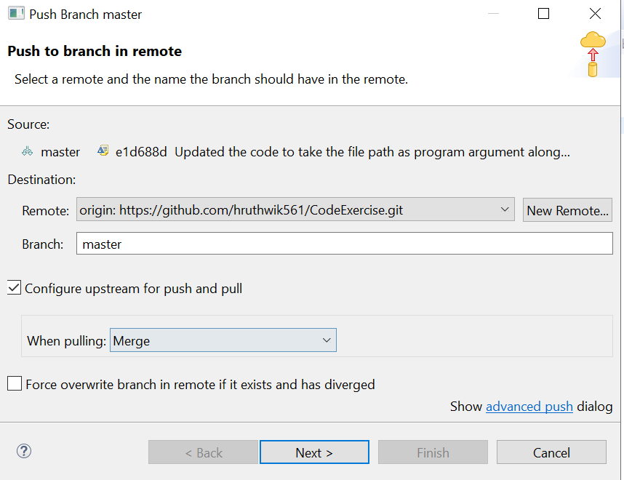
4. Right click on project -> Team -> Commit -> commit and push.

**Importing the project from GIT to local:**

1. Open command prompt and navigate to the directory to download the project using **cd directory_path** command.
2. Use git clone command to download the project to navigated directory, command is **git clone https://github.com/hruthwik561/CodeExercise.git.**

**Executing the Project:**

1. Import the downloaded project to Eclipse.
2. Give the input file location as program argument to the project(refer to the 1st image) and then run the project to get the output in console.